USING MIC

<http://tinkerlog.com/2007/05/20/cheap-sound-sensor-for-avr/>

<http://www.avrfreaks.net/index.php?name=PNphpBB2&file=viewtopic&p=568945>

<http://www.mare.ee/indrek/speakit/#microphone>

SPARK FUN ELECTRONICS

<http://www.sparkfun.com/products/8669>

<http://www.sparkfun.com/datasheets/BreakoutBoards/Amplified-Mic-v10.pdf>

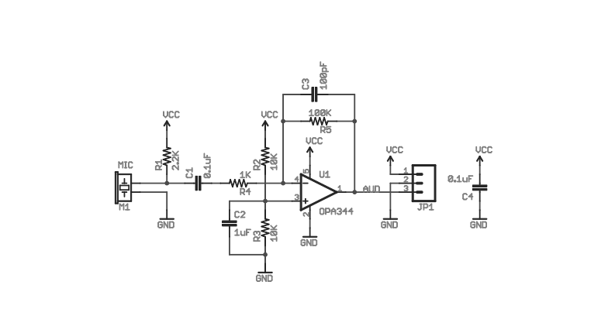

SOME PROJECT DETAILS

I came up with this idea purely because I had some free time over the weekend. Basically, I want to transmit audio signals (i.e. from a standard 1/8" audio jack) by laser (in essence, streaming it by laser to a speaker setup somewhere else). Most of my interest are not on the circuitry side of things, so I'd like some advice on how to go about doing it.   
  
I decided to start simple by AM modulating the laser, by connecting a mono input to a 8-1000ohm audio transformer (connecting it to the power supply [2x11.5V AA batteries in this case] and then to the power terminals of a modified run-of-the-mill 5mW laser pointer. For the receiver, I just used a Cd-S photocell connected to one 1.5V AA battery (because the headphone jack RMS is 1.5V if not a bit under), which. of course, is connected to the output mono jack. This setup is quite cheap and comes with a few obvious problems:  
  
(a) Environmental conditions such as humidity, precipitation, etc. degrades the intensity which has a direct impact on output levels.   
(b) The setup only works for mono, 1-channel sound.   
  
I was wondering if any of you could offer any guidance on cheap-to-implement modulation methods that could allow stereo sound in two channels to be sent (solving (b)). Also, is there any way to normalize the signal, so that the effects of factors mentioned in (a) would be minimized?   
  
Out of curiosity, is there any kind of documentation that gives the intensity to resistance relation of Cadmium-Sulfide photocells? I was thinking of using higher intensity lasers because the ones advertised on eBay are garbage. I ordered a couple of 532nm (green) 50mW lasers for another idea of mine, and their measured intensities were around 20-30mW with roughly 20-40% of the light emitted being IR (1064nm).  
  
Anyhow, any help in improving my idea would be appreciated.

If you only want telephone quality then an8bit adc at 8khz would be enough - you can do this with a very simple PIC micro then you can transmit the data digitally however you want.  
You aren't going to be able to send a purely AM signal more than a very short distance in ideal conditions. Look at using a telescope (or just a simple lens) at each end to produce a wider collimated beam.  
It's called free space optical communications if you want to hit google.  
  
ps You do not want to be doing this with more than class 1 (<5mW) laser pointers.

<http://www.physicsforums.com/showthread.php?t=269405>

<http://hackedgadgets.com/2010/05/13/send-music-over-a-laser-beam/>

<http://www.instructables.com/id/Send-Music-over-a-Laser-Beam/>

<http://sci-toys.com/scitoys/scitoys/light/light.html#laser_communicator>

1. A transformer of the type known as an audio output transformer. It consists of an 8 ohm coil and a 1000 ohm coil. The one I used is the Radio Shack #273-1380. We now carry them [in our catalog](https://www.scitoyscatalog.com/).

AUDIO AUTPUT TRANSFORMER

<http://www.geofex.com/article_folders/xformer_des/xformer.htm>

<http://www.jensen-transformers.com/an/Audio%20Transformers%20Chapter.pdf>

<http://www.radioshack.com/product/index.jsp?productId=2103254>

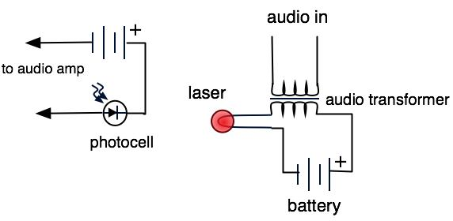

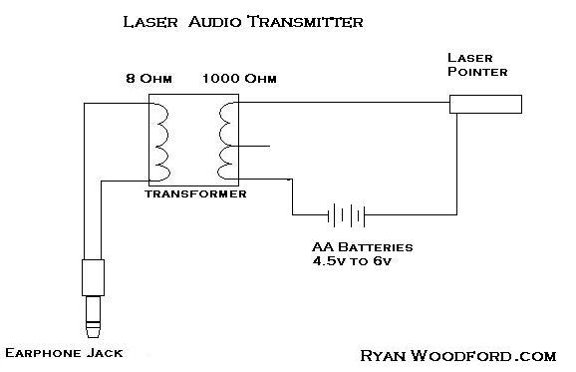

The transformer *modulates* the power going to the laser. The signal from the radio is added to and subtracted from the battery power, and the laser gets brighter and dimmer along with the volume of the music or voice in the signal.